Current Situation:

Medical plan 2 @ step 1 : 5040

Accident Plan 2@Step 2 3000

Life Plan 2@ Step 4 926

Saving 2@ Step 5 18000

C1_B1

TOCH isn’t matched

Note: In Game is larger than the excel by 5040(Medical plan)

Net Cash Flow is correct, but TCOH isn’t.

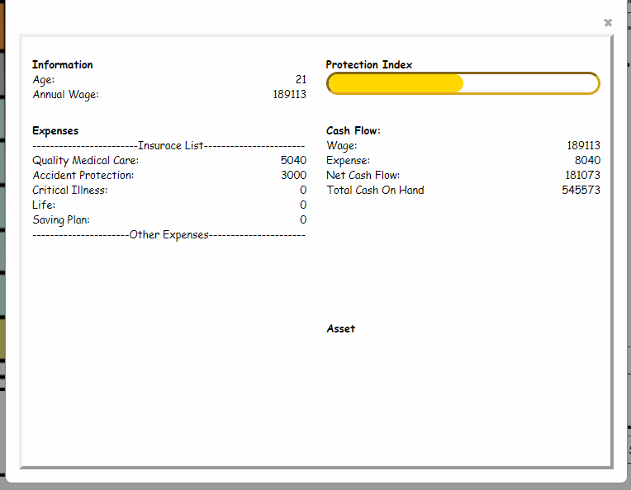

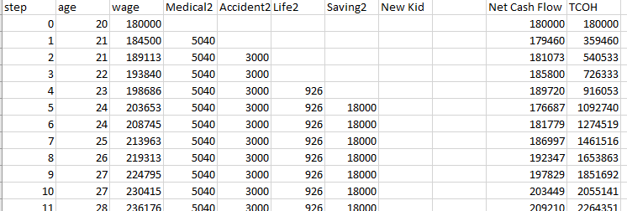



C1_B2